Core Java
James Gosling – 1995/6 sun microsystem @oracle
March > java 24v, September 25v(2025)
JAVA(JSE ,JEE,JME)
Java two imp features
Platform independent (JVM)
Garbage collector – automatically manage memory.
By removing objects->no longer referenced by running program
JDK(developer tools)>JRE(libraries)>JVM
Java Execution Process
file.java------>compilation(compiler)----->byte code(ClassName.class)--àJVM---àOS execution
JVM Architecture
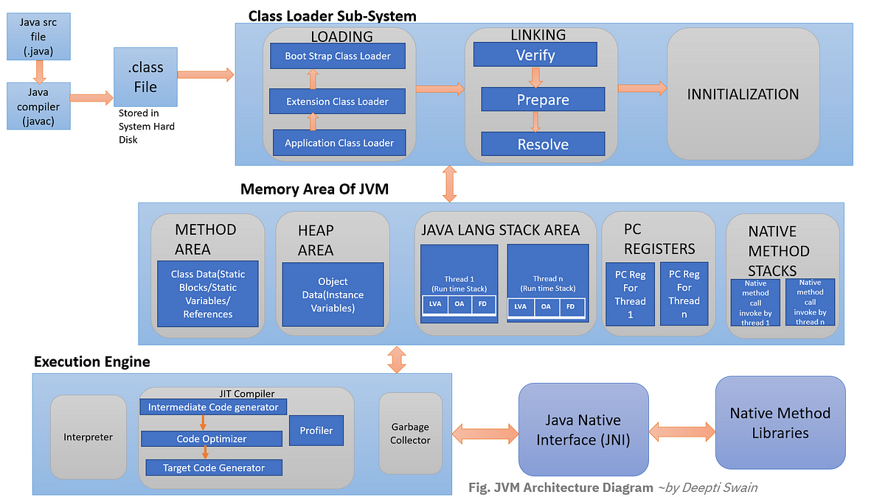
LVA - Local Variable Array OS - Operand Stack FD – Framed Data
Interpreter – line by line execution, byte code to native machine code
JIT (Just In Time) compiler - track count of method, once threshold reaches JIT compiles and generates corresponding native code for direct use
Garbage collector – collect and removes unreferenced object
Program execution starts from main method and from Right to left
Pascal case for class name
Camal case for objects,variables,methods
Identifiers - names used to identify and refer to various elements like variables, methods, classes, and interfaces (a-z A-Z 0-9 _ $) valid name
Default package file – java.lang Default Parent class– java.lang.object
Enumeration – Representing a group of named constants,
Syntax -> “enum” keyword similar to class no need to use new keyword,public static final
Can have method,variable and constructor
Enum Day{
Mon,
Tue,….}
Day d=Day.Mon;
Day dàobject creation Switch(Day) case Mon:
Java variables:
Data container ->stores value
Syntax: datatype variable_name;(variable declaration)
variable_name=value;(variable initialization)
Three Types: Local, Instance and Static variable
Local variable | Instance Variable | Static Variable
Syntax: Inside the block | Inside class - outside block | Static keyword,  Inside class - outside block
Memory: stack (method exec) | Heap (object creation) | Method area(class loading)
Access: Direct | Obj.var_name | Class.var_name
Usage : block scope data | Unique data | Common data

class Guru99 {
static int a = 1; //static variable-initialized once ->class loading
int data = 99; //instance variable
void method() {
int b = 90; //local variable
}
}

Datatype->designates type & quantity of value to hold
Primitive ->fixed size, no methods or properties, faster performance, stored directly in memory without overhead associated with object reference
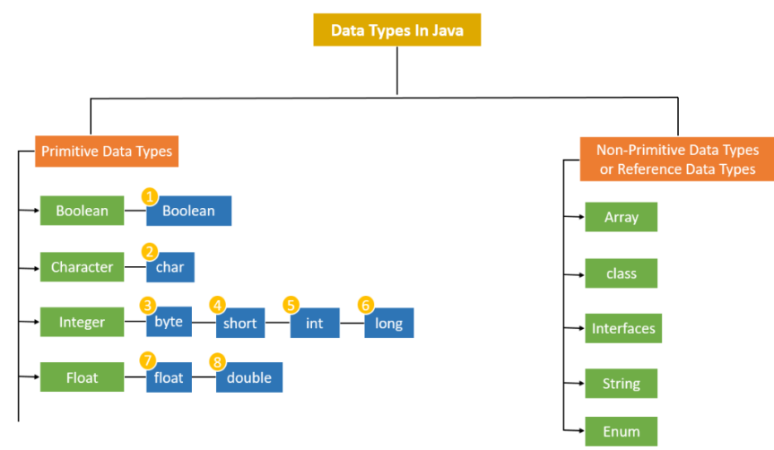
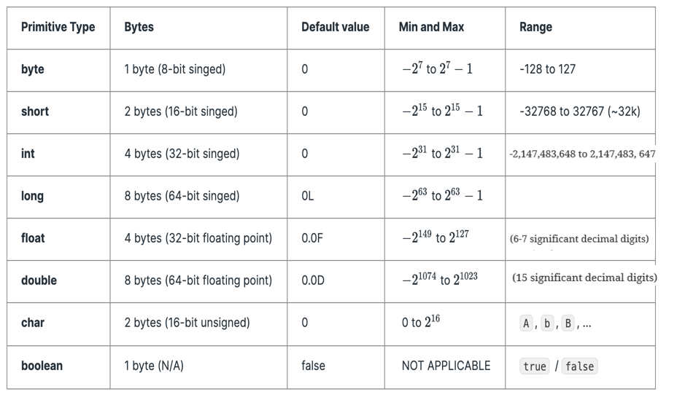
Operators:
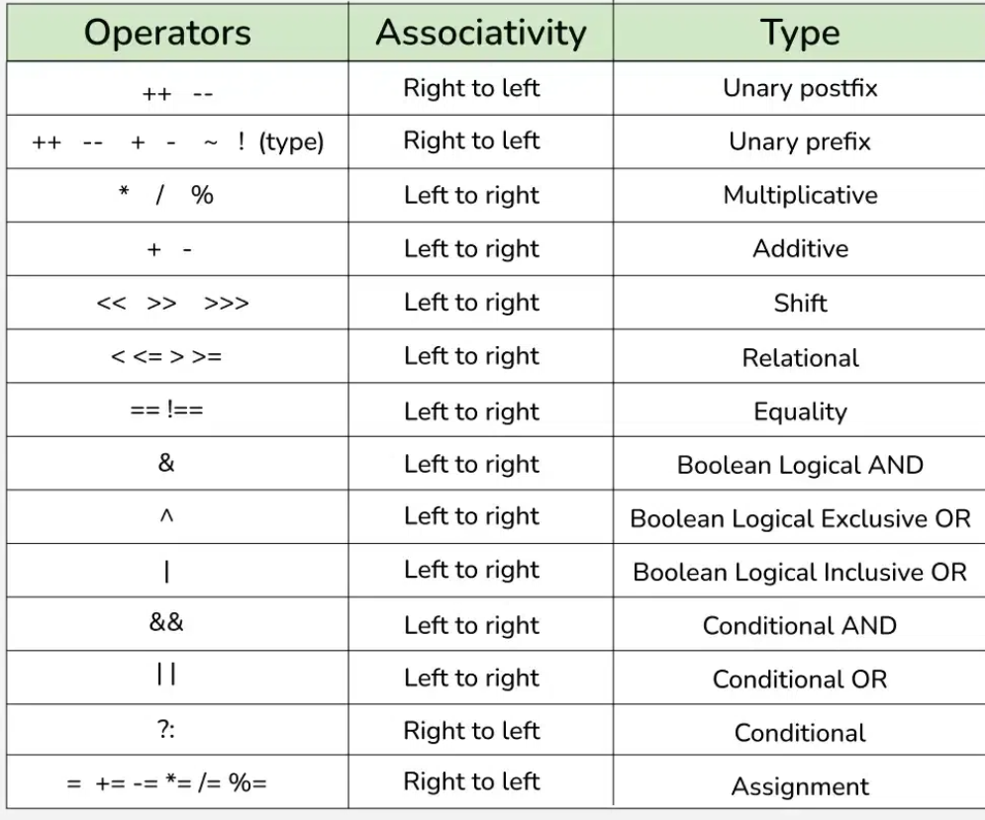
Control flow
If-else,while,do-while,for-each for,switch(condition)-case num:,default,break,continue,
do{  //statement;  }  while(condition); | for (dtype iter_name : var_name){  sopln(iter_name);  }

OOPS
Object Oriented Programming Structure ---àOOPL
Advantage->Performance and security
Class is a collection of data members and member function(virtual)
Object instance of class(physical)
Method: access_modifer static/instance rtype name(parameters)
class Main {
void multiply (int a,int b){
System.out.println("multiplication:"+(a*b));
}
public static void main (String args[]){
Main m=new Main ();
m.multiply(1,2);
} }
Security
Encapsulation - Binding/wrapping of data and its corresponding methods together
Abstraction - Hiding implementation details and providing essential functionalities only
Performance
Inheritance - Extending properties of one class to other
Polymorphism – ability of method or object to take many form
- Abstraction
Achieved abstract class or Interface
Use abstract keyword
Abstract method – method without implementation
Class – only concrete methods
Abstract class – combination of concrete and abstract methods
Interface – only abstract methods (multiple inheritance & 100% abstraction achieve)
Interface - > class implements keyword
Interface -> Interface, class -> class extends keyword
Java supports multiple inheritance using interface
Interface variable -> public static final, methods->abstract
- Inheritance
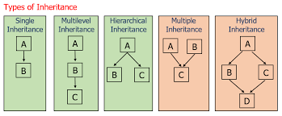
- Polymorphism
Method overloading Method Overriding(@Override )
Compile-Time polymorphism Run-Time polymorphism
Same name -Different method signature Same name – same method signature
4.Encapsulation
Using getters and Setters to access data
Keywords:
This keyword: current class properties(class,object,constructor,method,variable)
Super: Parent class properties(class,constructor,method,variable)
Final: variable cannot update,method cannot override,class cannot extendable
Constructor: object creation Method:
Name Same as class name different name
Type: default/parameterized defined/parameterized
No return type return type present
Access Modifiers
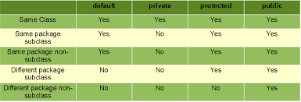

Class A {  Public void m1(){ sopln(“parent m1”);  }  Class B extend A{  @override  Public void m1(){  sopln(“child m1”);  }  Public void m2(){  sopln(“child m2”);  }  B(){  sopln(“default constructor”);  }  B(String s){  sopln(“parameterised constructor”);  }  } | Public static void main(String args[]){  A obj=new B(“hi”);  Obj.m1(); //child m1  }

Java 8 features (focused on enable functional programming)
Interface changes
- Default and static methods (method implementation inside interface)
- Static not able to override
Functional Interface (single abstract method, used to invoke lambda expression)
Rep @FunctionalInterface
Lambda expression (anonymous function)
- no name - no modifier - no return type
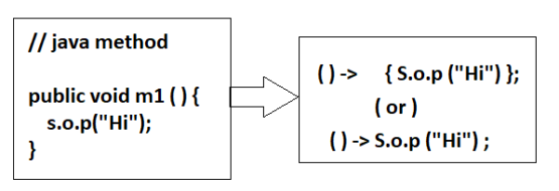
some predefined functional interfaces
predicate – conditional check (returns true/false) test(T)
function – take input and return output
consumer –take input no output
supplier – no input but produce output value when get() method invoked
Method references
1.static method reference class_name::method_name
2.instance method reference object_name::method_name
3.constructor reference class_name::new
Optional class -> used to deal with nullpointer exception
To avoid abnormal termination
container object that can hold a value or be empty
Stream API
The uses of Stream in Java are mentioned below:
- Stream API is a way to express and process collections of objects.
- Enable us to perform operations like filtering, mapping, reducing, and sorting.

@SpringBootApplication annotation in Spring Boot combines the functionality of @Configuration, @EnableAutoConfiguration, and @ComponentScan

